**INCOME STATEMENT**

The Income Statement presents the financial results of a business for a stated period of time. The statement quantifies the amount of *revenue* generated and *expenses* incurred by an organization during a reporting period, as well as any resulting net *profit* or *loss*. Also known as *the profit and loss statement* or the *statement of revenue and expense*, the income statement primarily focuses on the company’s revenues and expenses during a particular period. Change the **Branch**, **Date Range** *(Start Date and End Date)* as filters for the report *(Figure 1)*. Click the **Print Report Button** to print *(Figure 2)*, **Export Button** to save the report to an Excel File *(Figure 3)*, and **Email Button** to email the excel file to the designated address in the **Settings -> Email Report Settings**.

**Figure 1**

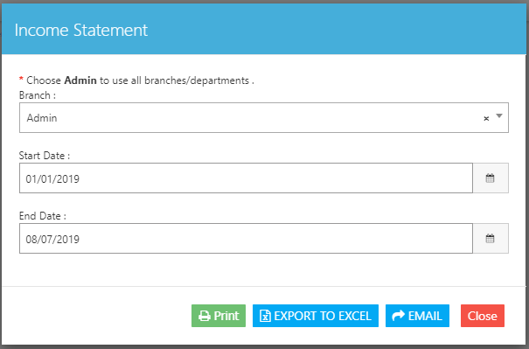

**Figure 2 Figure 3**

